
RAMAIAH
Institute of Technology
USN | 1 | M | S

(Autonomous Institute, Affiliated to VTU)
(Approved by AICTE, New Delhi & Govt. of Karnataka) Accredited by NBA & NAAC with ‘A’ Grade

MAKE UP EXAMINATIONS – APRIL 2021
Program | : | B.E. : Electrical and Electronics Engineering | Semester | : | VII
Course Name | : | Power Systems - II | Max. Marks | : | 100
Course Code | : | EE72 | Duration | : | 3 Hrs

Instructions to the Candidates:
- Answer one full question from each unit.
- Suitably assume any missing data.

 |  | UNIT- I
1. | a) | With neat sketch Model the 𝜋-equivalent circuit of transformers with off-nominal turns ratio used in formation of bus admittance matrix. | CO1 | (08)
 | b) | What are primitive element and primitive network? Mention an example for each. | CO1 | (04)
 | c) | For the network shown in Fig. 1(c) obtain the bus admittance matrix Y_{BUS} by singular transformation analysis. The line data is as shown in the table below.  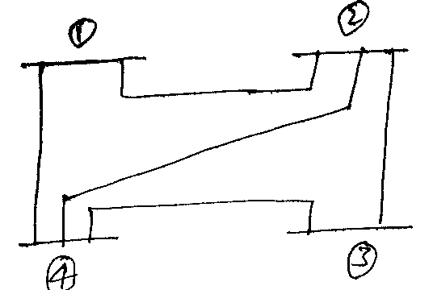  Fig. 1(c) | CO1 | (08)
  Line  No | Connecting  nodes | Admittance (pu)
  1 | 1-4 | 1.4
  2 | 1-2 | 1.6
  3 | 2-3 | 2.4
  4 | 3-4 | 2.0
  5 | 2-4 | 1.8
2. | a) | 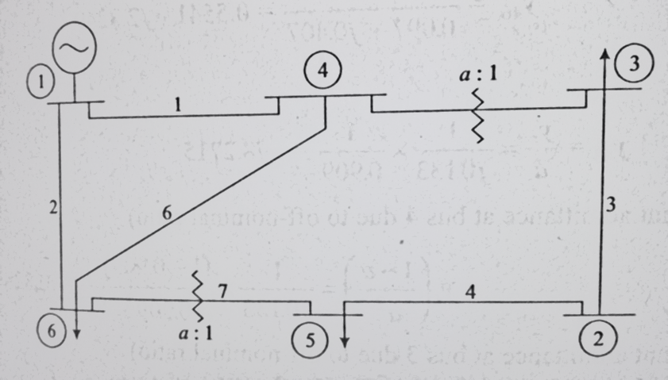  Fig. 2(a)  Consider the power system shown in Fig. 2(a) and corresponding data is given in Table 2.a. A static shunt capacitor is connected at bus 4 with admittance j0.005pu. Formulate the Y-Bus using inspection method.  Table 2.a | CO1 | (10)
  Element | From-To Bus | Line impedance | Half line charging admittance | Off-nominal turn ratio.
  1 | 1-4 | 0.08+j0.37 | 0.007 | --
  2 | 1-6 | 0.123+j0.518 | 0.010 | --
  3 | 2-3 | 0.723+j1.05 | 0.0 | --
  4 | 2-5 | 0.282+j0.64 | 0.0 | --
  5 | 4-3 | 0.0+j0.133 | 0.0 | 0.909
  6 | 4-6 | 0.097+j0.407 | 0.0076 | --
  7 | 6-5 | 0.0+j0.3 | 0.0 | 0.976
 | b) | Derive the step-by-step algorithm for formation of bus impedance matrix, when an element is added to the partial network is branch. | CO1 | (10)
 |  | UNIT – II
3. | a) | Obtain the expressions of jacobian of Newton Raphson’s power flow model. | CO2 | (10)
 | b) | What is the significance of power flow analysis in a power system? Discuss the classification of various types of buses in a power system for load flow studies. | CO2 | (06)
 | c) | Compare gauss Seidel and Newton raphson methods for power flow analysis. | CO2 | (04)
4. | a) | Obtain the power flow solution at the end of first iteration using Gauss Seidel method for the network shown in Fig.4(a).  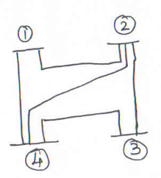  Fig.4(a) | CO2 | (10)
  SB | EB | R | X
  1 | 2 | 0.05 | 0.15
  1 | 3 | 0.1 | 0.3
  2 | 3 | 0.15 | 0.45
  2 | 4 | 0.1 | 0.3
  3 | 4 | 0.05 | 0.15
  Bus No | P  (pu) | Q  (pu) | V  (pu)
  1 | - | - | 1.04∠0
  2 | 0.5 | -0.2 | -
  3 | -1.0 | 0.5 | -
  4 | -0.3 | -0.1 | -
 | b) | List the data essential for the power flow? | CO2 | (06)
 | c) | What is slack bus? Explain the significance of it in the power flow analysis. | CO2 | (04)
 |  | UNIT – III
5. | a) | In a system with 2 plants, the incremental fuel costs are given by:  IC₁ = 0.01P_{G1} + 20 Rs/ MWh  IC₂ = 0.015P_{G2} + 22.5 Rs/ MWh  The system is running under optimal scheduling with P_{G1}= P_{G2}=100MW. If incremental transmission loss of generator 2 is 0.2, find the penality factor and incremental transmission loss of generator 1. | CO3 | (06)
 | b) | Distinguish between the problem of unit commitment and economic dispatch. | CO3 | (04)
 | c) | Derive the transmission loss formula in terms of B-coefficients. | CO3 | (10)
6. | a) | The fuel cost functions in Rs./h for 3 thermal plants are given by:  F₁ = 350 +7.2 P_{G1} +0.004 P²_{G1}  F₂ = 500 +7.3 P_{G2}+0.0025 P²_{G2}  F₃ = 600 +6.74 P_{G3}+0.003 P²_{G3}  P_{G1}, P_{G2} and P_{G3} are in MW. Find the optimal schedule and compare the cost of these, when the generators share the load equally. Given P_{D}=450MW. | CO3 | (10)
 | b) | Compute the loss coefficients for the network shown in the Fig. 6(b), using the following data:  I_{a}= 1.0-j0.15PU, I_{b} = 0.5-j0.1PU, I_{c} = 0.2-j0.05PU  Z_{a} = 0.02-j0.15PU, Z_{b} = 0.03-j0.15PU, Z_{c} = 0.02-j0.25PU  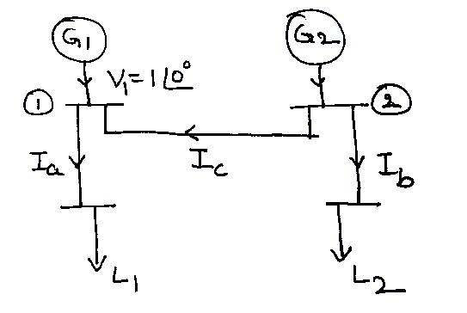  Fig. 6(b) | CO3 | (10)
 |  | UNIT – IV
7. | a) | With help of a flow chart, explain the method of finding transient stability of a given power system using modified Euler’s method. | CO4 | (10)
 | b) | Explain the solution of swing equation by point-by-point method. Mention the assumption made. | CO4 | (10)
8. | a) | With the of flow chart explain how transient stability studies are carried out using Runge-Kutta method. | CO4 | (10)
 | b) | Explain clearly the representation of synchronous machine and load for transient stability studies. | CO4 | (10)
 |  | UNIT – V
9. | a) | What is load frequency control? Explain with a block diagram, the model of a load frequency control for an isolated power system. | CO5 | (10)
 | b) | Write a brief note on:  (i) Series Compensation and (ii)FACTS Controllers. | CO5 | (10)
10. | a) | Explain the objectives and functions of ALFC and AVR loops in a power system with a neat block diagram. | CO5 | (10)
 | b) | Write a brief note on:  (i) Load Compensation and (ii) Line Compensation. | CO5 | (10)

****************

